• Even after accepting or rejecting the RFI, the status is still showing as “Verify.” The “Verified” status should be displayed only after the RFI inspection has been completed.
• The Field Engineer’s remarks are not visible in the GP history. The remarks entered by the Field Engineer should be displayed in the GP history.
• After attending the RFI, both photographs should be displayed in the GP login history: the GP Field Photo and the Field Engineer (FE) Field Photo.
• After submitting the RFI request, the photo should be viewable in the RFI History under the GP login. The button name should be “GP Field Photo.”
• The RFI create request Form should be available in Hindi, as it is currently displayed in English.
• The report should also be available and visible for all web user logins.

Getting Null in Sub Category - need to check in db
date of inspection
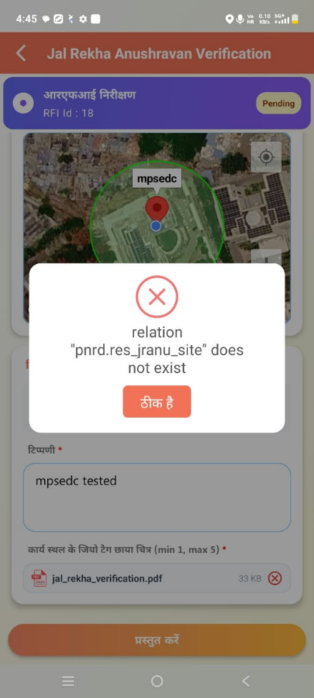

Issue While Submiting Form by FE
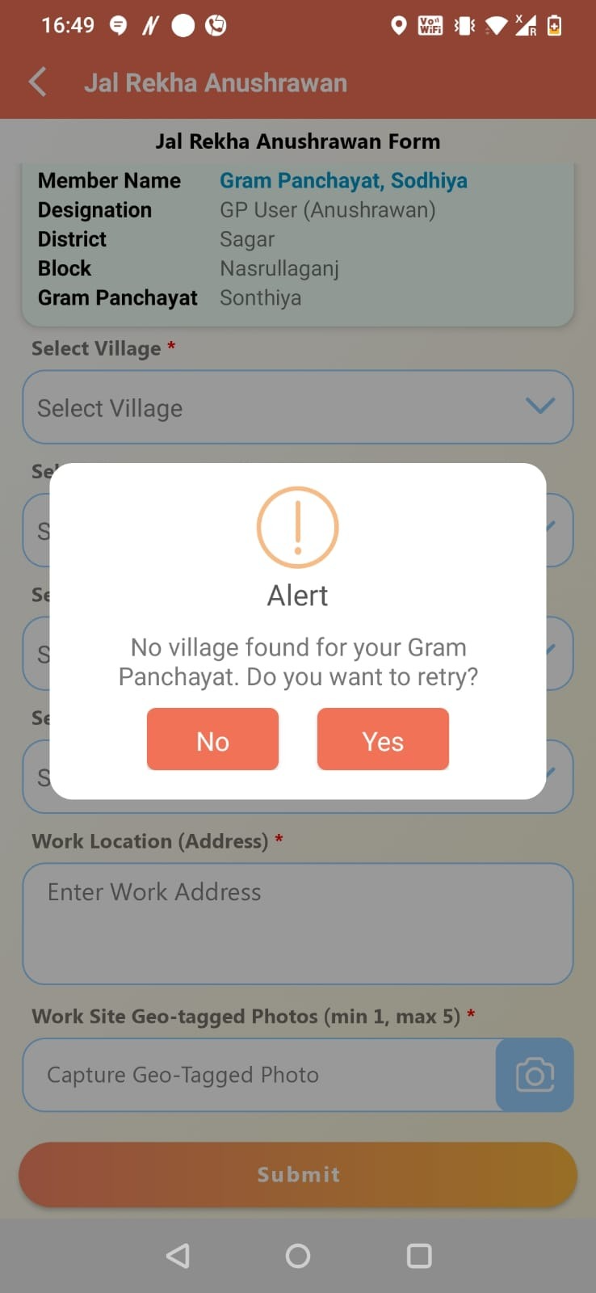

Village not show in GP login users ,plz ck
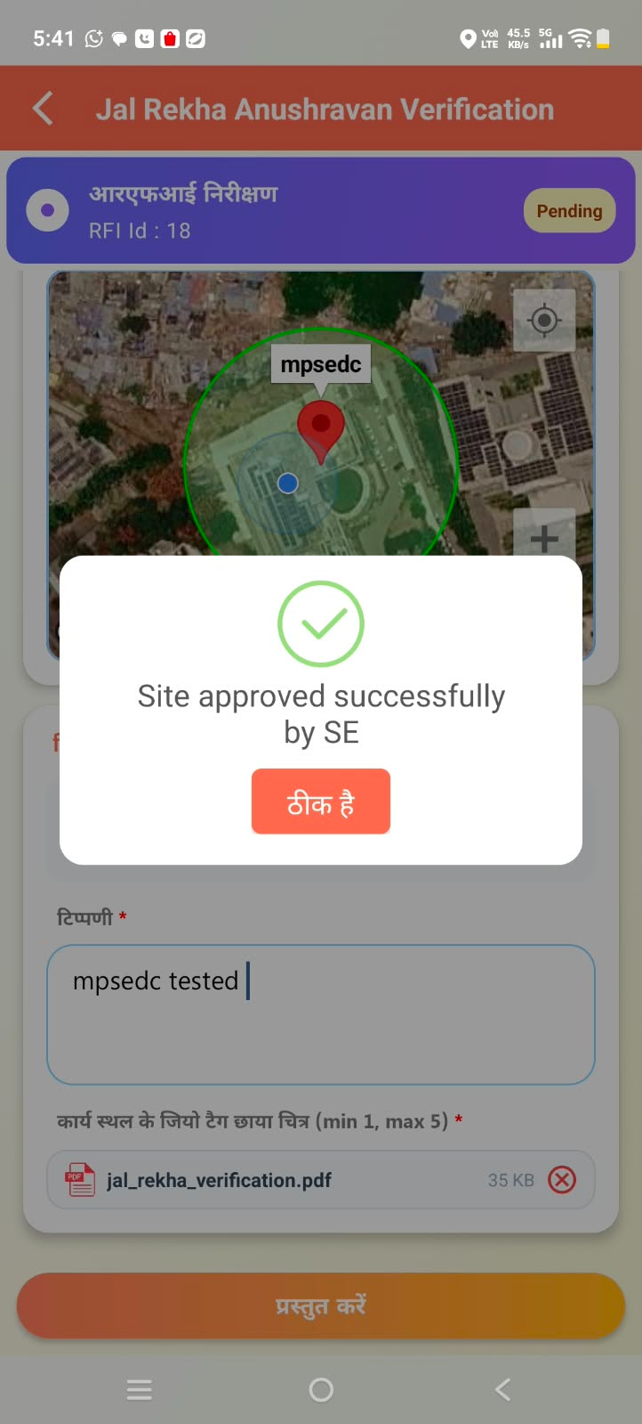

RFI Submitted Successfully... please show the message
RFI history not visible after successful submission of RFI by SE.

RFI History Tab is not visible

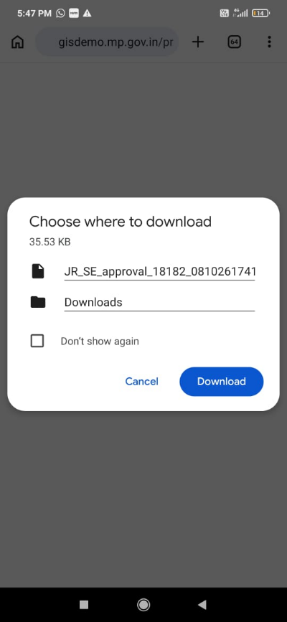

In GP login RFi history plz view the photograph ( don’t show in download way)

Name of the Module inside SIPRI App - "ANUSHRAWAN". Do not write "Jal Nigam GP"

Name of the user

Sub Engineer. Do not write "Jal Nigam FE"
Anushravan is the correct spelling
The issues reported earlier are still unresolved. I also sent a reminder in the group yesterday. Kindly look into these issues and resolve them at the earliest.Plz discuss
yesterday evening tapan sir raised some issues
1. Display message SE submission will be " RFI submitted successfully"2. History list is not available at SE login
3. Photos need to be viewed in jpg instead of url
Villages are visible under the dummy user, but they are not appearing in the village dropdown when logging in with the GP user ID. Kindly check and resolve this issue at the earliest.Thanks Rahul
so in that case share Genuine GP user credentials and their mobile number to login
in Web user GP login in reports - sub category column is showing Null empty fields

And reports should be visible to all web users logins created.

